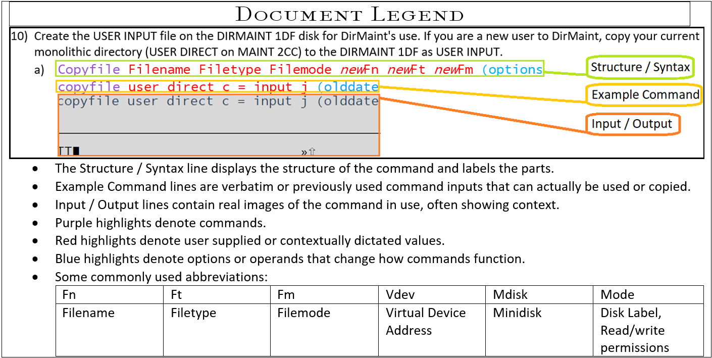

1. (Step 1 is necessary only for second level VM’s) Identify a free DASD, detach it from system and attach it to the Virtual Machine you wish to apply it to
   1. **Query** *device options*  
      **Q** *DASD* *free*
      1. Choose a dasd marked FREE and note its device address (2D49 here)
   2. **Detach** *device from target***Det** *2D49 from system*
   3. **Attach** *device to target*  
      **Att** *2D49 to VM00JA*
   4. **Logon** to a privileged user on the target VM or zVM level (Instructions following this take place in the environment intended to receive the new dasd.)
2. Attach DASD to privileged user and invoke ICKDSF to perform formatting
   1. **Attach** *device to target*  
      **Att** *2D49 \**
      1. *(to* is a default option and does not need to be input. Asterisk * when attaching attaches to current user)
   2. **ICKDSF  
      ICKDSF** *console console*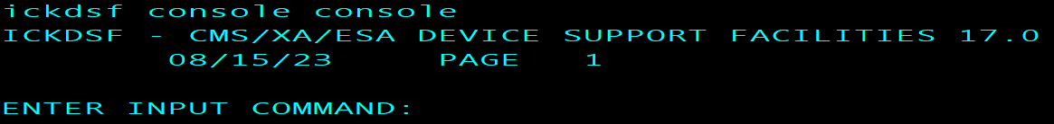
   3. **CPVOL Format** **unit(***device) options* **volid(***namelabel***) range**(#,#) **CPVOL Format unit***(2D49) noverify* **volid***(JORLNX)* **range**(1,10016)  
      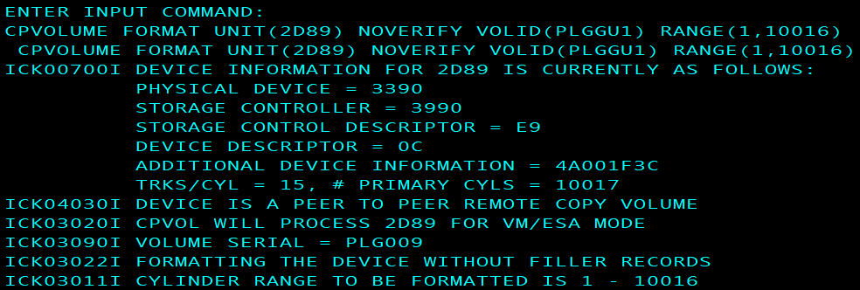
   4. **Reply** ‘**U**’ to proceed  
      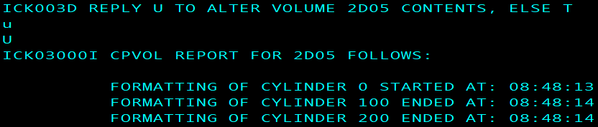
   5. **END**  
      **END**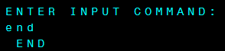
3. Request, acquire and edit the Extent Control file, then file it back to DIRM
   1. **DIRM** *Send fn ft* **DIRM** *send**Extent**Control*
   2. **Receive** *spoolid (options***Receive** *225 (replace*
   3. **Filelist** *fn ft fm***Filel** *extent control a  
      *And or:
   4. **Xedit** *fn ft fm***Xedit** *Extent Control*
   5. Use double quote symbol “ on the prefix area to duplicate a line underneath itself  
      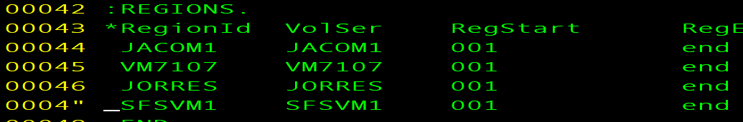  
      1. Overwrite the duplicate line with the new DASD’s Volser in the volser and RegionID columns
      2. Add a comment to inform/remind admins about the DASD’s purpose
      3. Input **File** to the xedit command line to save changes  
         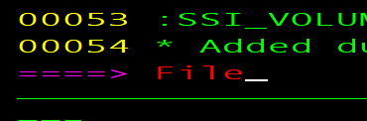
   6. **DIRM** *file fn ft***DIRM** *file Extent Control*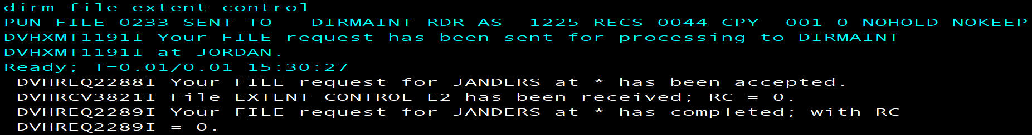
4. **Link** and **Access** PMAINT CF0 to edit System Config
   1. **Link** *device-name mdisk temporary-device# permissiontype***Link** *PMAINT CF0 5CF0 wr*  
      
   2. **Access** *temporary-device# filemode***Access** *5CF0 w*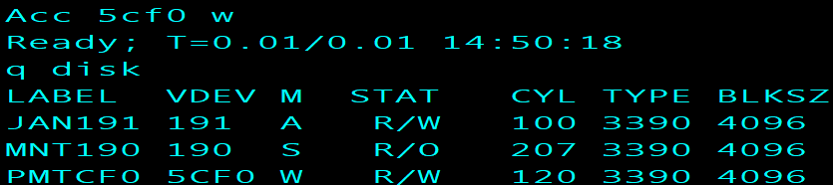

~OR~

* 1. **VMLink** *device-name*  *mdisk (operand***VMLink** *pmaint cf0 (write  
     *

1. Open System Config with **filelist** and **xedit** to add the new dasd’s volser (namelabel, volid) to User_Volume_List
   1. **Filelist** *fn ft fm***Filelist** *\* * w*And or:
   2. **Xedit** *fn ft fm* **Xedit** *System Config W*
   3. **/***searchterm***/***user_volume_list*
      1. The **/** forward slash searches for whatever characters come after it
   4. Write in a matching syntax entry for the new dasd using its volid (established earlier at step.2)c)) using the same method as with Extent Control  
      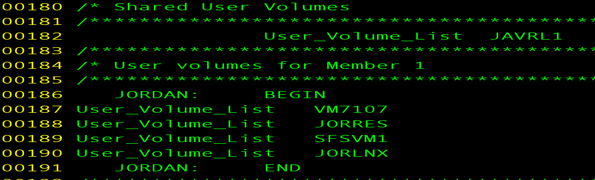
2. Apply changes to the extent control file
   1. **DIRM** *operand***DIRM** *rlde*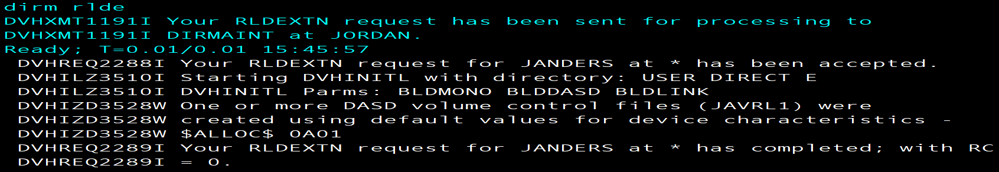
3. Verify changes have taken place by checking the User Mdiskmap from DIRM
   1. **Dirm** *operand***dirm** *Dirmap*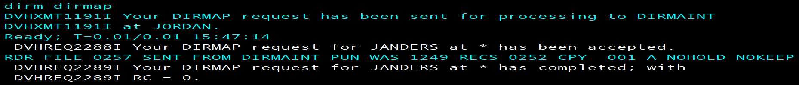
   2. **Receive** *spoolid options***rec** *257 (rep*
   3. **Xedit** *fn ft fm***x user mdiskmap**
   4. **/***newlyaddedvolid***/***JORLNX*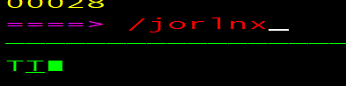
   5. Confirm



1. Finished!